**Class 4 Lab questions**

#1. WAP to find the largest between two numbers.

Code:

#include <stdio.h>

int main()

{

    printf("Provide the numbers you want to compare:\n");

    float a285,b285;

    scanf("%f%f",&a285,&b285);

    if (a285<b285) {

        printf("The larger number is %f",b285);

    }

    else {

        printf("The larger number is %f",a285);

    }

    return 0;

}

Output:

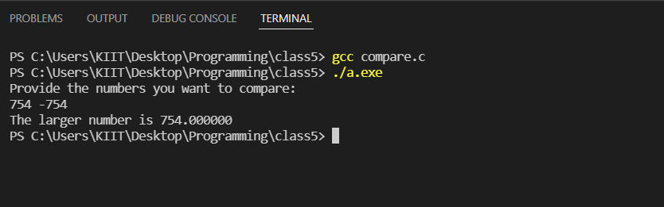

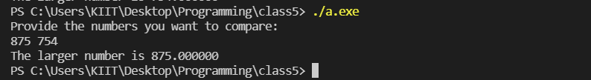

#2. WAP to determine whether a year entered through the keyboard is a leap year or not.

Code:

#include <stdio.h>

int main()

{

    printf("please provide the year:\n");

    int year285;

    scanf("%d",&year285);

    if ((year285%4==0 && year285%100!=0) || (year285%400==0))

    {

        printf(" %d is a leap year\n",year285);

    }

    else{

        printf("%d is not a leap year\n", year285);

    }

    return 0;

}

Outputs:

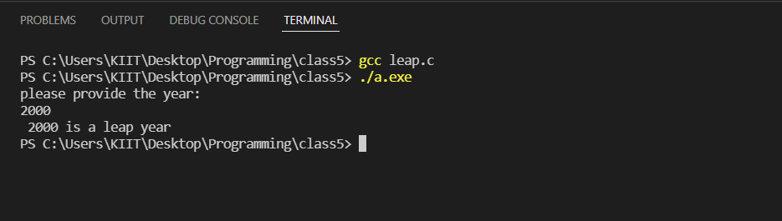

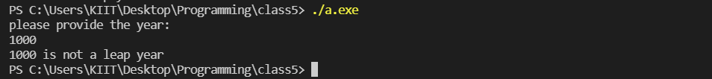

#3. WAP to input any three integers distinct and display the greater of three integers.

Code:

#include <stdio.h>

int main()

{

    printf("please provide any 3 distinct numbers\n");

    int a285,b285,c285;

    scanf("%d %d %d", &a285, &b285, &c285);

    if (a285!=b285 && b285!=c285 && a285!=c285)

    {

        if(a285>b285 && a285>c285)

            {

                printf("%d is the greatest number\n",a285);

            }

        else if (b285>a285 && b285>c285)

        {

            printf("%d is the greatest number\n",b285);

        }

        else if (c285>a285 && c285>b285)

        {

            printf("%d is the greatest numebr\n",c285);

        }

        else{

            printf("wow\n");

        }

    }

    else

    {

        printf("Your numbers must be distinct!\n");

    }

    return 0;

}

Output:

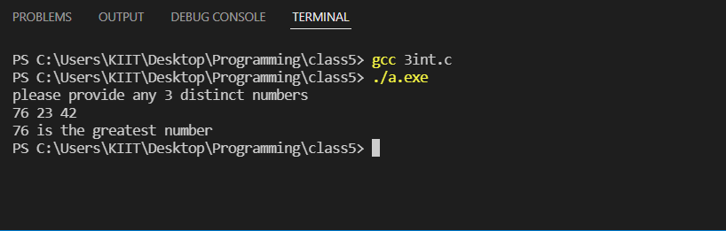

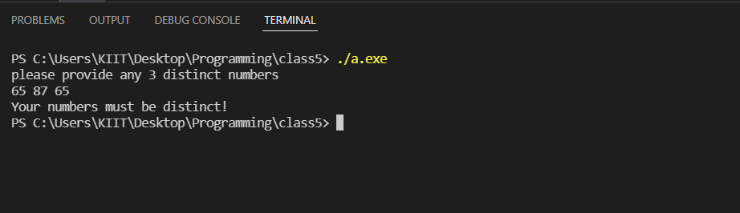

#4. WAP to display the grade system of KIIT University based on total marks secured by a student in a semester. Use switch-case statement.

Code:

#include <stdio.h>

int main()

{

    int mark285,tm285;

    printf("Provide your mark\n");

    scanf("%d",&mark285);

    tm285 = mark285/10;

    switch(tm285){

        case 9: printf("secured grade is O\n");

        break;

        case 8: printf("secured grade us E\n");

        break;

        case 7: printf("secured grade is A\n");

        break;

        case 6: printf("secured grade is B\n");

        break;

        case 5: printf("secured grade us C\n");

        break;

        case 4: printf("secured grade is D\n");

        break;

        default: printf("FAIL");

    }

    return 0;

}

Output:

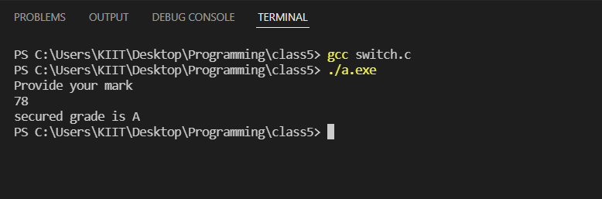

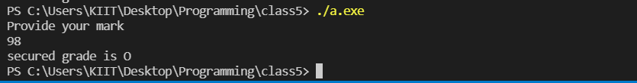

#5. WAP to input any two integers, and provide a menu to the user to select any of the options as add, subtract, multiply, divide and display the result accordingly.

Code:

#include <stdio.h>

int main()

{

    printf("which operation do you want to perform:\n");

    int a285,c285;

    printf("1 for addition\n");

    printf("2 for subtraction\n");

    printf("3 for division\n");

    printf("4 for multiplication\n");

    scanf("%d", &a285);

    int one285,two285;

    printf("please provide the numbers you want to operate with;\n");

    scanf("%d%d",&one285,&two285);

    switch(a285)

    {

        case 4: c285=one285*two285;

        printf("%d",c285);

        break;

        case 3: c285=one285/two285;

        printf("%d",c285);

        break;

        case 2: c285=one285-two285;

        printf("%d",c285);

        break;

        case 1: c285= one285+two285;

        printf("%d",c285);

        break;

        default: printf("NA");

    }

    return 0;

}

Output:

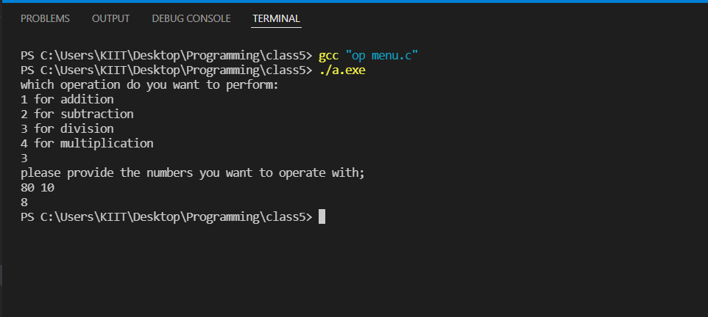

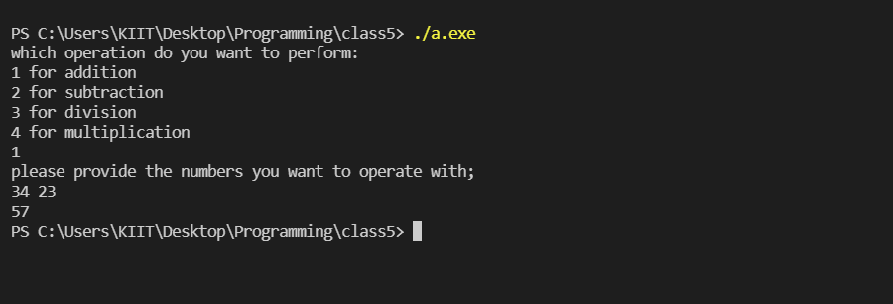

#6. WAP to display the grade system of KIIT University based on total marks secured by a student in a semester. Use else..if ladder statement.

Code:

#include <stdio.h>

int main()

{

    printf("Provide your grade:\n");

    int gr285;

    scanf("%d",&gr285);

    if (gr285>=90)

    {

        printf("You have secured an O\n");

    }

    else if(gr285>=80 && gr285<90)

    {

        printf("you have secured an E\n");

    }

    else if(gr285>=70 && gr285<80)

    {

        printf("youb have secured an A\n");

    }

    else if(gr285>=60 && gr285<70)

        printf("you have secured a B\n");

    else{printf("You have failed!!!");}

    return 0;

}

Output:

